|  |
| --- |
| **18EES101J-BASIC ELECTRICAL AND ELECTRONICS ENGINEERING (LAB)** |
| **RECORD**  **SEMESTER I**    **ACADEMIC YEAR: 2020-21**  **NAME : *Tambe Utkarsh Yashwant.***  **REG. NO. : *RA2011027010166***  C:\Users\System 1\Desktop\11.png  **DEPARTMENT OF ELECTRICAL & ELECTRONICS ENGINEERING**  **FACULTY OF ENGINEERING & TECHNOLOGY**  **SRM INSTITUTE OF SCIENCE AND TECHNOLOGY**  (Formerly SRM University, Under section 3 of UGC Act, 1956)  **S.R.M. NAGAR, KATTANKULATHUR – 603 203**  **KANCHEEPURAM DISTRICT** |



**SRM Institute of Science and Technology**

(Deemed to be University)

**S.R.M. NAGAR, KATTANKULATHUR -603 203**

**KANCHEEPURAM DISTRICT**

**BONAFIDE CERTIFICATE**

**Register No : *RA2011027010166***

Certified to be the bonafide record of work done by *Tambe Utkarsh Yashwant* of *Computer Science & Engineering department*, B.Techdegree course in the Practical of 18EES101J Basic Electrical and Electronics Engineering in **SRM IST, Kattankulathur** during the academic year 2018-2019. **Lab in-charge**

**Date: Year Co-ordinator**

Submitted for end semester examination held in______________________ Lab, SRMIST**,** Kattankulathur**.**

**Date: Examiner-1 Examiner-2**

**LIST OF EXPERIMENTS**

1. Verification of Kirchhoff’s laws

2. Verification of All Theorems (Thevenin’s theorem, Norton’s theorem, Maximum power transfer theorem)

3. Transient analysis of RL an RC series circuits

4. Load test on single phase transformer

5. Demo of DC/AC machines & Parts

6. Types of wiring (fluorescent lamp wiring, staircase wiring)

7. Characteristics of semiconductor devices (PN junction, Zener diode, BJT)

8. Wave shaping circuits (Half and full wave rectifier, clipper)

9. Displacement measurement using LVDT and pressure measurement using Strain gauge

10. Verification and interpretation of Logic Gates.

11. Reduction of Boolean expression using K-map

12. Study of modulation and demodulation techniques.

**INDEX**

|  |  |  |  |
| --- | --- | --- | --- |
| **Sl. No.** | **Name of the Experiment** | **Marks (50)** | **Signature**  **of the Staff** |
| 1 | Verification of Kirchhoff’s laws |  |  |
| 2 | Verification of All Theorems  (Thevenin’s theorem, Norton’s theorem, Maximum power transfer theorem) |  |  |
| 3 | Transient analysis of RL an RC series circuits |  |  |
| 4 | Load test on single phase transformer |  |  |
| 5 | Demo of DC/AC machines & Parts |  |  |
| 6 | Types of wiring ( fluorescent lamp wiring, staircase wiring) |  |  |
| 7 | Characteristics of semiconductor devices  (PN junction, Zener diode, BJT) |  |  |
| 8 | Wave shaping circuits  (Half and full wave rectifier, clipper) |  |  |
| 9 | Displacement measurement using LVDT and pressure measurement using Strain gauge |  |  |
| 10 | Verification and interpretation of Logic Gates. |  |  |
| 11 | Reduction of Boolean expression using K-map |  |  |
| 12 | Study of modulation and demodulation techniques. |  |  |

DEPT. OF ELECTRICAL & ELECTRONICS ENGINEERING

SRM INSTITUTE OF SCIENCE AND TECHNOLOGY, Kattankulathur – 603 203

|  |
| --- |
| Title of Experiment : **3**.**Transient analysis of Series RL, RC circuits** |
| Name of the candidate : *Tambe Utkarsh Yashwant*.  Register Number : *RA2011027010166*  Date of Experiment : *15th October, 2020* |

|  |  |  |  |
| --- | --- | --- | --- |
| Sl.  No. | Marks Split up | Maximum marks  (50) | Marks obtained |
| 1 | Pre Lab questions | 5 |  |
| 2 | Preparation of observation | 15 |  |
| 3 | Execution of experiment | 15 |  |
| 4 | Calculation / Evaluation of Result | 10 |  |
| 5 | Post Lab questions | 5 |  |
| **Total** | | **50** |  |

Staff Signature

**PRE LAB QUESTIONS**

**1. Define Transient.**

**Ans :** *A transient event is a short-lived burst of energy in a system caused by a sudden change of state. The source of the transient energy may be an internal event or a nearby event. The energy then couples to other parts of the system, typically appearing as a short burst of oscillation.*

**2. Time constant for RL Circuit.**

**Ans :** *The time constant for an RL circuit is defined by τ = L/R.*

**3.****Time constant for RC Circuit.**

**Ans :** *The time constant for an RC circuit is defined by τ = R* *x C.*

**4.****How will you design the values of L & C in a transient circuit?**

**Ans :**

|  |  |
| --- | --- |
| **Experiment No. 3**  **Date :** *15/10/2020* | **Transient analysis of series RL, RC circuits** |

**Aim:**

To obtain the transient response and measure the time constant of a series RL and RC circuit for a pulse waveform.

**Apparatus Required:**

|  |  |  |  |
| --- | --- | --- | --- |
| Sl. No. | Apparatus | Range | Quantity |
| 1 | Function Generator | 800 Hz | 1 |
| 2 | Inductor | 1 mH | 1 |
| 3 | Resistor | 4 KΩ | 1 |
| 4 | Capacitor | 1 nF | 1 |
| 5 | Bread Board & Wires | -- | Required |
| 6 | CRO |  | 1 |
| 7 | CRO Probes |  | 2 |

**Theory**

In this experiment, we apply a pulse waveform to the RL or RC circuit to analyze the transient response of the circuit. The pulse-width relative to a circuit’s time constant determines how it is affected by an RC or RL circuit.

Time Constant (τ): A measure of time required for certain changes in voltages and currents in RC and RL circuits. Generally, when the elapsed time exceeds five time constants (5τ) after switching has occurred, the currents and voltages have reached their final value, which is also called steady-state response.

The time constant of an RC circuit is the product of equivalent capacitance and the Thevenin’s resistance as viewed from the terminals of the equivalent capacitor.

τ = RC

A Pulse is a voltage or current that changes from one level to the other and back again. If a waveform’s high time equals its low time, as in figure, it is called a square wave. The length of each cycle of a pulse train is termed its period (T). The pulse width (tp) of an ideal square wave is equal to half the time period.

**Procedure for RL:**

1. Make the connections as per the circuit diagram.
2. Choose square wave mode in signal generator
3. Using CRO, adjust the amplitude to be 2 volts peak to peak.
4. Take care of the precaution and set the input frequency.
5. Observe and plot the output waveform.
6. Calculate the time required by the output to reach 0.632 times the final value (peak).
7. This value gives the practical time constant. Tabulate the theoretical and practical values.

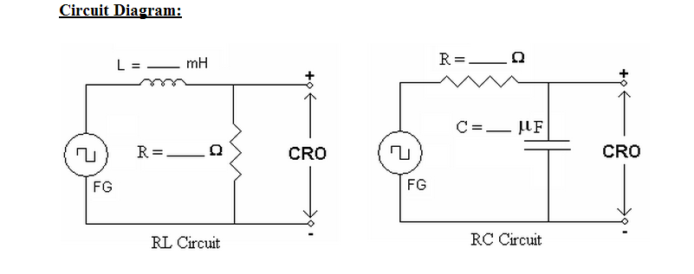

**Model Graph:**

**a) RL Transient :Output voltage across Resistor:**

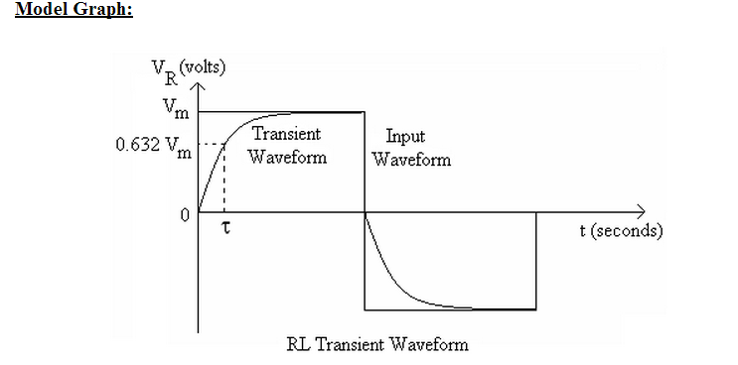

**b) RC Transient :Output voltage across Capacitor:**

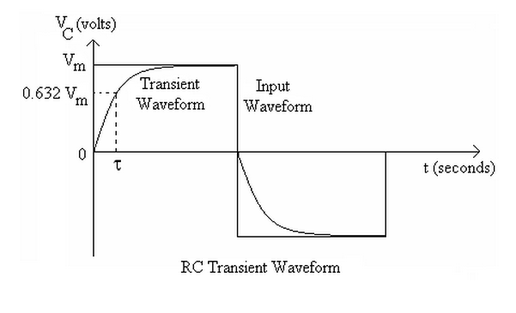

**Hardware setup:**

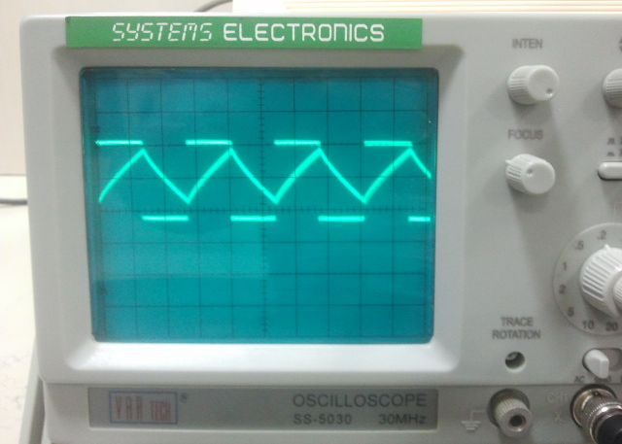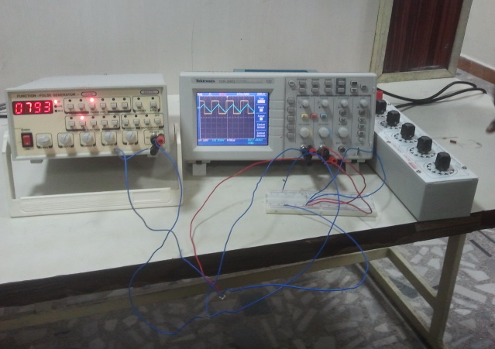

**Result:** *Thus, the transient response and the time constant of a series RL and RC circuit for a pulse waveform is verified.*

***Screenshots of E-Circuits with Resistor & Inductor.***

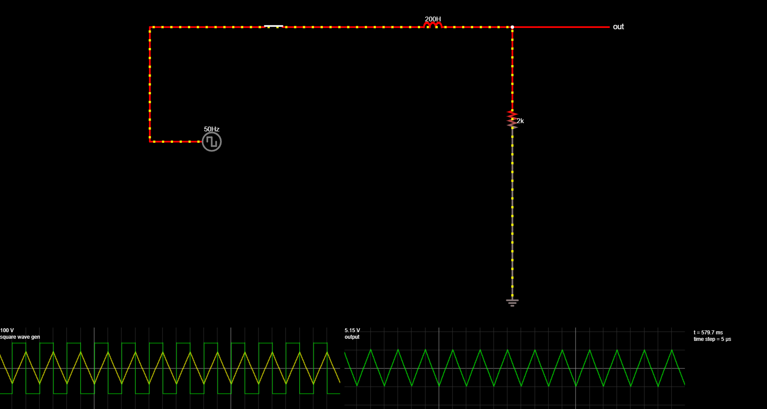

***Screenshots of E-Circuits with Resistor & Capacitor.***

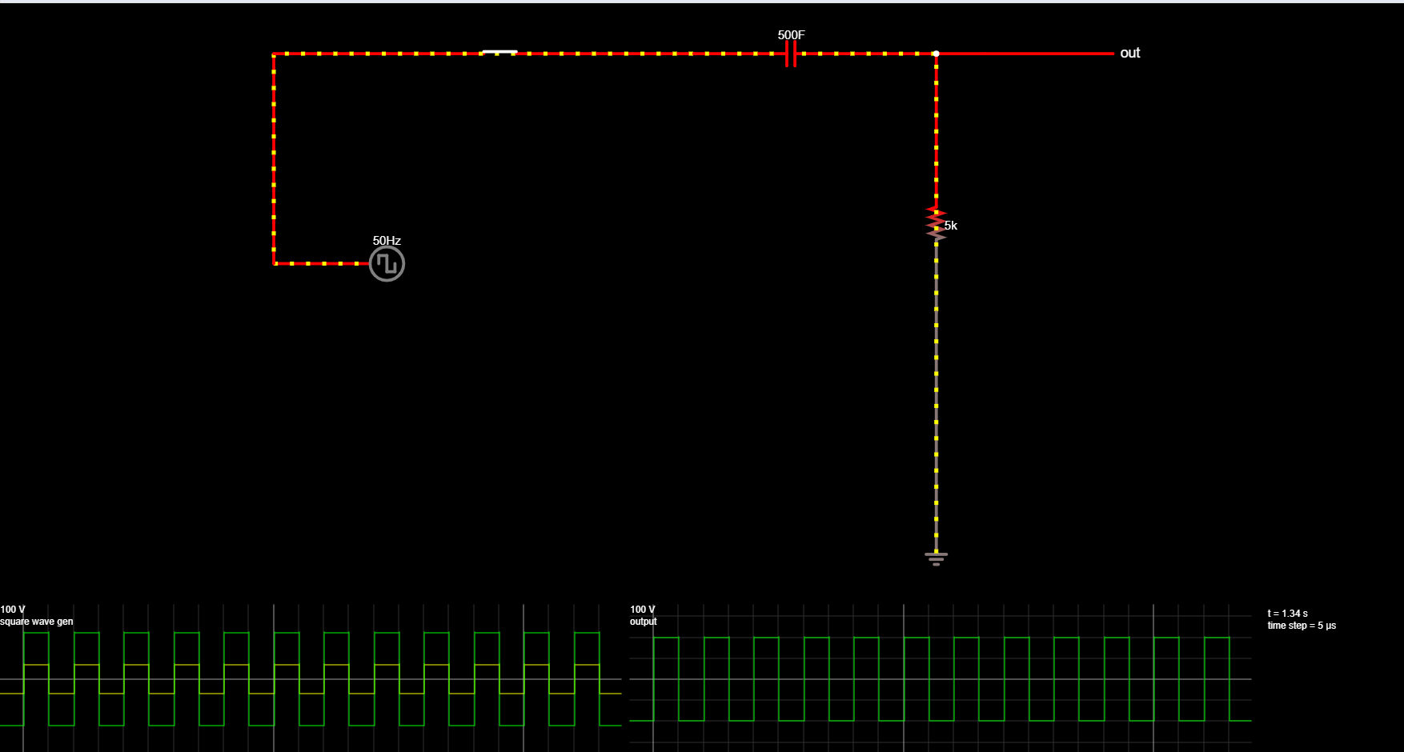

**POST LAB QUESTIONS**

**1.** **Why is it necessary to discharge the capacitor every time you want to record another transient voltage across the capacitor?**

**Ans :** *A charged capacitor left by itself will retain the charge for even months or years. So, when it is disconnected from supply, the instant voltage it carries across terminals is maintained, which could often be dangerous.*

**2. If the capacitor remains charged, what would you expect to see across the capacitor when you re-close the switch to try to record another transient?**

**Ans :**

**3. What does the derivative of a step function look like?**

**Ans :** *The derivative of a unit step function is called an impulse function.*

**4. What does the integral of a step function look like?**

**Ans :** *The derivative of a unit step function is called a ramp function.*